Legends

Fig. 1: Early glaucomatous ONH. The inferior rim is thinner than normal one.

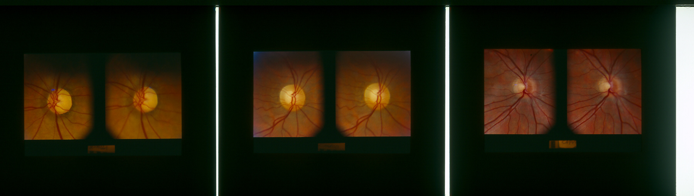

Fig. 2

NTG HTG VF 2.pdf