A theoretical investigation of the increase in venous oxygen saturation levels in advanced glaucoma patients

Lucia Carichino¹, Alon Harris², Giovanna Guidoboni^{1, 2, 3}, Brent A. Siesky², Luis Abegão Pinto⁷, Evelien Vandewalle⁵, Olof B. Olafsdottir⁴, Sveinn H. Hardarson⁴, Karel Van Keer⁵, Ingeborg Stalmans^{5, 6}, Einar Stefansson⁴, Julia C. Arciero¹

¹Department of Mathematical Sciences, Indiana University-Purdue University Indianapolis, Indianapolis, IN, United States; ²Department of Ophthalmology, Indiana University School of Medicine, Indianapolis, IN, United States; ³LABEX Institut de recherche en mathématiques, interactions et applications, Strasbourg, France; ⁴Department of Ophthalmology, University of Iceland, Reykjavik, Iceland; ⁵Department of Ophthalmology, University Hospitals Leuven, Leuven, Belgium; ⁶Department of Ophthalmology Neurosciences, Laboratory of Ophthalmology, Katholieke Universiteit Leuven, Leuven, Belgium; ⁷Department of Ophthalmology, Centro Hospitalar Lisboa Norte, Lisbon, Portugal

Correspondence: Julia C. Arciero, Department of Mathematical Sciences, 402 N. Blackford St., LD 270 D Indianapolis, IN 46202-3267.
E-mail: jarciero@math.iupui.edu

Abstract
Purpose. Vascular changes have been observed among glaucoma patients, but it is not yet known whether these vascular changes occur primary or secondary to glaucomatous damage. In this study, a theoretical mathematical model of the retinal vasculature is applied to a set of oximetry data obtained from healthy individuals and glaucoma patients and is used to propose possible explanations for the clinically observed increases in venous blood oxygen saturation in advanced glaucoma patients.
Methods. Given clinical measurements of intraocular pressure (IOP), mean arterial pressure and arterial blood oxygen saturation from healthy persons and advanced (visual field mean defect (MD) ≥ 10 dB) primary open angle glaucoma (POAG, IOP > 21 mmHg) patients and advanced normal tension glaucoma (NTG, IOP ≤ 21 mmHg) patients, the model is used to predict the oxygen demand or Krogh cylinder tissue width that would yield the clinically-measured venous oxygen saturation in each population.
Results. A decrease in retinal tissue oxygen demand ${(M}_{0})$, an impairment in blood flow autoregulation, or a decrease in Krogh cylinder tissue width $(d)$ can independently lead to increased venous saturation. The model predicts that a decrease in $M_{0}$ or a decrease in $d$ is more likely to yield the increased venous saturation levels observed in POAG patients, while impairing blood flow autoregulation with no change in $M_{0}$ or $d$ is more likely to yield the increased venous saturation levels observed in NTG patients.
Conclusions. The combined theoretical and clinical model predictions suggest that the mechanisms leading to increased venous saturation might differ between POAG and NTG patients. The model predictions are used to hypothesize that a decrease in oxygen demand might be more relevant to explain the increase in venous saturation observed in advanced POAG, while impairment in autoregulation mechanisms might be more relevant to explain the increase in venous saturation observed in advanced NTG.
Keywords: blood flow autoregulation, glaucoma, mathematical model, oximetry, oxygen saturation, oxygen consumption, retina, spectrophotometry

Introduction
Glaucoma is a progressive optic neuropathy associated with visual field loss and retinal ganglion cell death. Although glaucoma progression has been primarily associated with elevated levels of intraocular pressure (IOP), recent studies have suggested that metabolic alterations, dysfunctions of vascular autoregulation and changes in oxygen supply to tissue are also relevant factors to be considered in the progression of the disease ^{1, 2}. The correlations between retinal metabolic alterations and vision loss are not yet fully understood; however, alterations in the retinal blood oxygen saturation levels of glaucomatous patients have been observed ³⁻⁶. Also, blood flow deficiencies reported in retinal and retrobulbar vessels⁷⁻¹¹ of glaucoma patients support the hypothesis that hemodynamic alterations are correlated to glaucoma damage, independent of or related to IOP ^{12, 13}. Alterations in the microvascular network density (and thus oxygen supply to tissue) in the optic disc and temporal areas have also been reported in glaucoma patients when compared with healthy individuals ¹⁴⁻¹⁶.

Despite this evidence linking blood flow alterations with glaucoma, it is still unknown whether vascular changes occur primary or secondary to retinal ganglion cell loss. If primary, impaired autoregulation or insufficient blood supply to the retina and optic nerve would lead to tissue damage with subsequent vision loss. If secondary, vascular changes would be the result of optic nerve damage and the loss of retinal ganglion cells, since those cells would no longer require oxygen or nutrient.

Several techniques can be used to measure vascular alterations in the eye, including fluorescein angiography, color Doppler imaging, laser Doppler flowmetry, Doppler optical coherence tomography and retinal oximetry^{2, 17, 18}. In particular, retinal oximetry can be used to measure hemoglobin oxygen saturation and vessel diameters in the retina^{4, 6, 19-22}. While many oximetry studies^{4, 6, 19-22} have been conducted among healthy individuals and patients with various types and severity of glaucoma, trends in the oximetry measurements were not consistent across studies. For example, some studies ^{6, 19} found no differences in venous oxygen saturation levels of normal-tension glaucoma (NTG) and high-tension primary open-angle glaucoma (POAG) patients when compared with the levels in healthy individuals, while other studies ^{4, 20-22} found significant differences in venous oxygen saturation among these populations.

In three studies^{3, 4, 20}, patients with advanced glaucoma (visual field mean defect (MD) ≥ 10dB) exhibited higher venous oxygen saturation levels (and thus a lower arteriovenous difference in oxygen saturation) compared with healthy individuals and mild glaucoma patients (MD ≤ 5dB). These observations led to the hypothesis that the decreased arteriovenous difference in the advanced glaucoma group could be due to a decrease in retinal oxygen consumption, but additional and preferably longitudinal studies in glaucoma patients are necessary to help to distinguish if the observed vascular changes occur primary or secondary to glaucoma damage.

As evident from the inconsistent trends in reported clinical data, additional methods are needed before definitive conclusions can be made relating blood oxygen saturation changes and the severity or type of glaucoma. This study applies a previously developed theoretical model of retinal vascular wall mechanics ²³ to a set of clinical oximetry data obtained from healthy individuals and glaucoma patients ⁴ to propose possible explanations for the increases in venous oxygen saturation observed in advanced glaucoma patients. The combined mathematical and clinical approach is used to calculate theoretical changes in blood oxygen saturation in retinal arterioles, capillaries and venules and to compute patient-specific levels of tissue oxygen demand or Krogh tissue width (herein referred to as “tissue width”) that would yield the measured values of venous oxygen saturation given values of mean arterial pressure (MAP = (2*DBP+SBP)/3), where DBP is diastolic blood pressure and SBP is systolic blood pressure), IOP and arterial oxygen saturation from patients. The resulting theoretical predictions provide a wider range of possible factors that could explain clinical observations than would be intuitive, and these results offer an important step in distinguishing between the primary causes and secondary effects of glaucoma.

Methods
Experimental data
Retinal oximetry is a clinical technique used to assess oxygen saturation levels and vessel caliber in individuals with various ocular diseases. This study focuses on oximetry data in patients with different types and degrees of severity of glaucoma. The methods of performing retinal oximetry and obtaining baseline measurements of factors such as IOP and blood pressure in glaucoma patients and healthy individuals has previously been described in detail ⁴. In short, measurements from 89 healthy individuals and 74 glaucoma patients of age 40 years or older were collected. Individuals with systemic diseases or ocular diseases other than open angle glaucoma were excluded from the study. However, patients receiving antihypertensive medication for elevated systemic blood pressure and patients with mild cataracts were not excluded.

Glaucoma was defined based on the characteristic optic disc damage and on the corresponding visual field defects. Of all of the glaucoma patients considered in this study, 45 were diagnosed with POAG and 29 were diagnosed with NTG. A diagnosis of POAG was defined by an untreated IOP >21 mmHg. Patients with IOP measurements consistently ≤21 mmHg were classified as having NTG. All glaucoma patients underwent automated perimetry. A patient was defined as having “mild glaucoma” if the visual field mean defect (MD) was ≤ 5 dB and was defined as having “advanced glaucoma” if the visual field MD ≥ 10 dB. Of the 45 POAG patients, 20 were diagnosed with mild glaucoma and 12 were diagnosed with advanced glaucoma. Of the 29 NTG patients, 13 were diagnosed with mild glaucoma and 9 were diagnosed with advanced glaucoma. Some patients were under active treatment at the time of measurement.

All oximetry measurements were performed in darkness with the Oxymap T1 oximeter (Oxymap ehf, Reykjavik, Iceland), where relative oxygen saturation was measured semi-automatically with the Oxymap Analyzer Software 2.2.1 (v.3847). The IOP measurements were performed on dilated pupils using a Goldmann applanation tonometry mounted on a Haag-Streit slit lamp (Haag-Streit BQ 900, Haag-Streit International, Köniz, Switzerland) in Belgium, and using the iCare TAO1 tonometer (Tiolat Oy, Helsinki, Finland) in Iceland. An automatic sphygmomanometer was used to obtain all measurements of systolic and diastolic blood pressures after a 5 min resting period (in Belgium: Omron HEM-7001-E, Omron, Kyoto, Japan; in Iceland: Omron HEM-7221-E, Omron, Kyoto, Japan).

Mathematical model
To determine possible explanations for measured changes in venous oxygen saturation in POAG and NTG patients⁴, a simplified mathematical model of the retinal vasculature, previously developed by Arciero et al. ²³, is used. The retinal vasculature downstream of the central retinal artery (CRA) and upstream of the central retinal vein (CRV) is modeled as a representative segment network, where five vessel compartments for the large arterioles (LA), small arterioles (SA), capillaries (C), small venules (SV) and large venules (LV) supplying and draining the retina are connected in series; each compartment consists of identical segments arranged in parallel (see Fig. 1). All compartments are assumed to experience the same hemodynamic and metabolic conditions. A summary of the model equations, along with its input values and output values, is provided in Table 1. The subscripts used in Table 1 indicate if the quantity is evaluated either at the inlet (in,i), midpoint (mp,i) or outlet (out,i) of the $i$th compartment, where $i=$LA,SA,C,SV,LV. The values of the model parameters are listed in Tables 2, 3 and 4. In the following, the main features of the model are discussed, which are leveraged to perform the simulations reported in the Results section. For a complete description of the model we refer to a previous study by Arciero et al.²³.

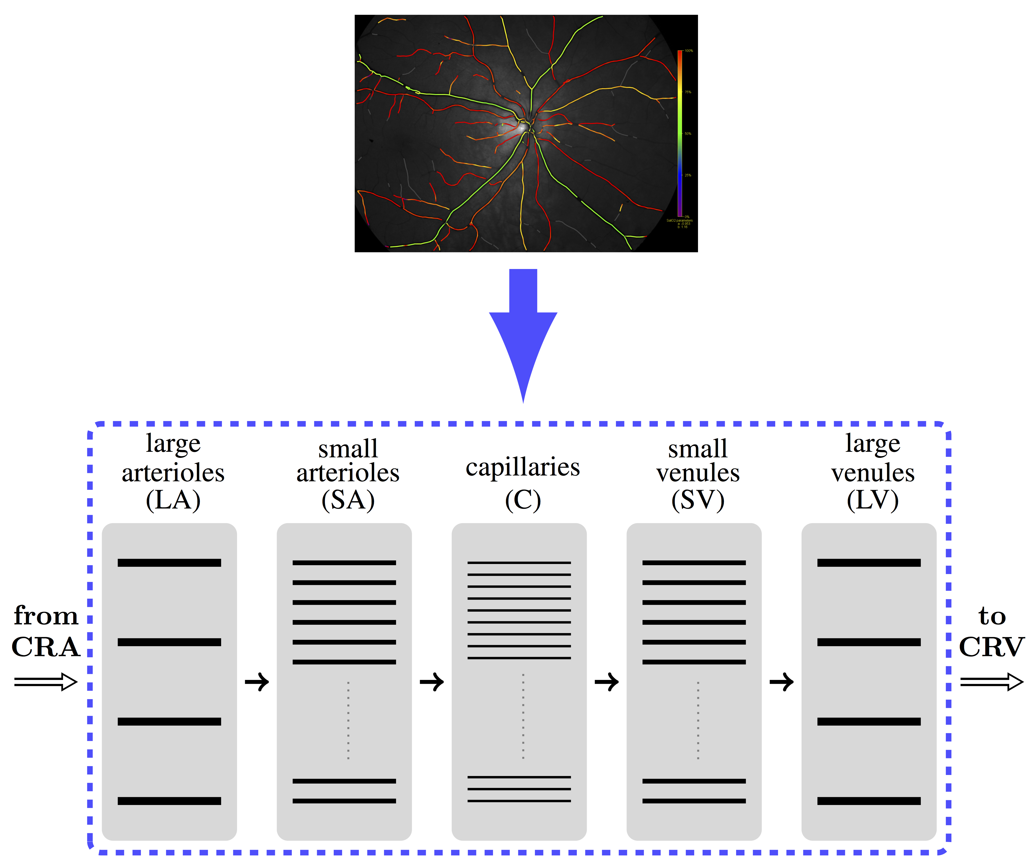
Figure 1. The retinal vasculature, as depicted in the oximetry image (top), is modeled as a representative segment network (bottom) consisting of five compartments of parallel-arranged vessels connected in series downstream of the central retinal artery (CRA) and upstream of the central retinal vein (CRV): Large arterioles/arteries (LA), small arterioles (SA), capillaries (C), small venules (SV) and large venules/veins (LV).

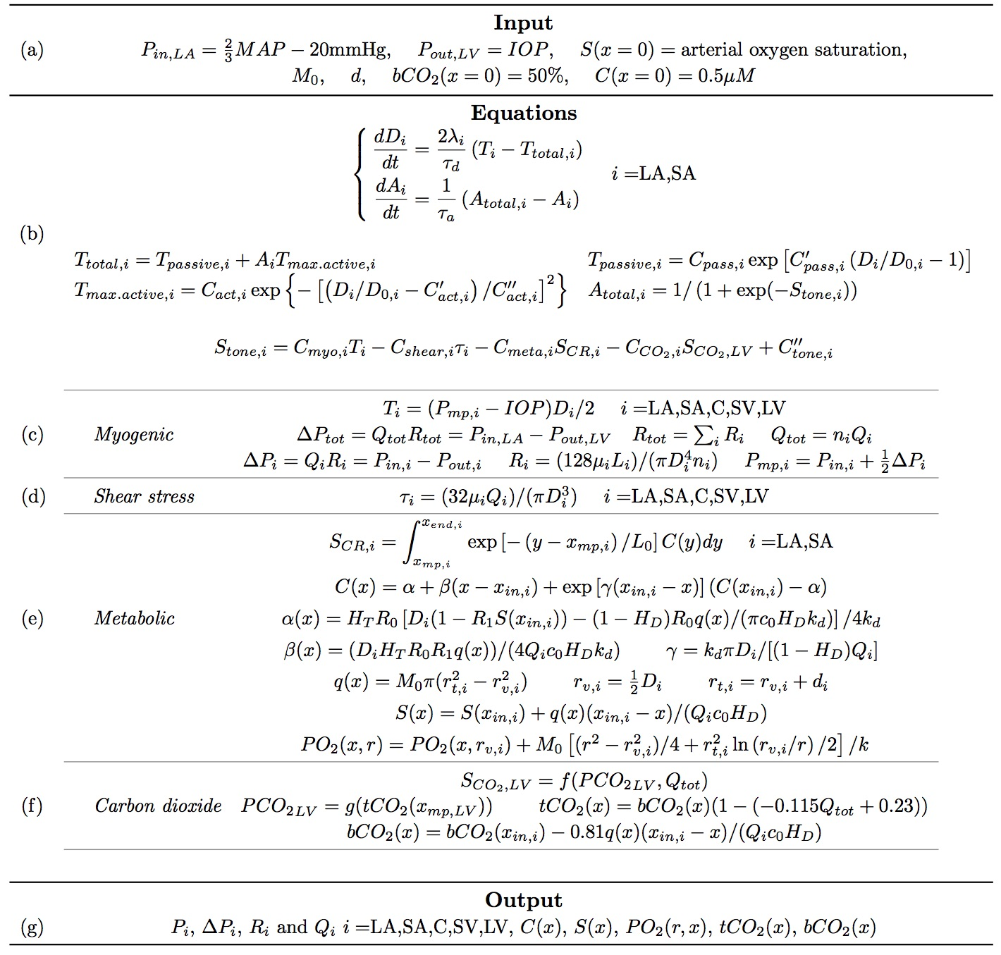

Table 1. Summary of model²³ variables and equations (sections b – f), including input (section a) and output (section g) data.

Constant | Value |  | Unit |  | Constant | Value |  | Unit
 | LA | SA |  |  |  | LA | SA
$$C_{pass}$$ | 361.48 | 197.01 | [$dyn/cm$] |  | $$C_{myo}$$ | 0.0092 | 0.025 | [$cm/dyn$]
$$C_{pass}^{'}$$ | 53.69 | 17.60 | [$1$] |  | $$C_{shear}$$ | 0.0258 | 0.0258 | [$cm^{2}/dyn$]
$$C_{act}$$ | 2114.2 | 3089.6 | [$dyn/cm$] |  | $$C_{meta}$$ | 200 | 200 | [$μM/cm$]
$$C_{act}^{'}$$ | 0.93 | 1.02 | [$1$] |  | $$C_{CO_{2}}$$ | 8$e^{-4}$ | 1.31$e^{-4}$ | $[1/mmHg$]
$$C_{act}^{''}$$ | 0.11 | 0.20 | [$1$] |  | $$C_{tone}^{''}$$ | 159.26 | 62.27 | [$1$]
$$λ$$ | 0.0457 | 0.0604 | [$1/mmHg$] |  | $$D_{0}$$ | 135.59 | 73.9 | [$μm$]

Table 2. Parameter values for passive tension, active tension, and vascular smooth muscle activation equations in the large arterioles (LA) and small arterioles (SA).

Parameter | Value | Unit
time constant for diameter, $τ_{d}$ | 1 | [$s$]
time constant for activation, $τ_{a}$ | 60 | [$s$]
tube hematocrit, $H_{T}$ | 0.3 | [$1$]
discharge hematocrit, $H_{D}$ | 0.4 | [$1$]
rate of ATP degradation, $k_{d}$ | 2$e^{-4}$ | [$cm/s$]
maximum rate of ATP release, $R_{0}$ | 1.4$e^{-9}$ | [$mol s^{-1} cm^{-3}$]
effect of oxygen saturation on ATP release, $R_{1}$ | 0.891 | [$1$]
oxygen capacity of red blood cells, $c_{0}$ | 0.5 | [$cm^{3}O_{2}/cm^{3}$]
oxygen tissue diffusion coefficient, $k$ | 9.4 | [$cm^{3}O_{2} cm^{-1}mmHg^{-1}s^{-1}$]
length constant for $S_{CR}$, $L_{0}$ | 1 | [$cm$]

Table 3. Time constants for the model equations (Table 1(b)) and parameter values for the metabolic response (Table 1(e)).

Parameter | Value |  |  |  |  | Unit
 | LA | SA | C | SV | LV
number of segments, $n$ | 4 | 39 | 111,360 | 39 | 4 | [$1$]
segment length, $L$ | 0.807 | 0.583 | 0.088 | 0.583 | 0.807 | [$cm$]
viscosity, $μ$ | 2.28 | 2.06 | 10.01 | 2.09 | 2.44 | [$cP$]

Table 4. Parameter values describing vessel network geometry and viscosity.

Blood flow and oxygen saturation throughout the network are predicted according to hemodynamic and mechanical principles. Retinal flow is assumed to follow Poiseuille’s Law, in which flow through each vessel is proportional to the fourth power of the vessel diameter. The complex blood rheology is accounted for by assigning different values of the apparent viscosity $μ$ to vessels in each compartment according to an experimental in vivo relationship²⁴ (Table 4). The total tension $T_{total,i}$ generated in the vessel walls of the vasoactive compartments $i=$ LA, SA follows the Law of Laplace and is modeled as the sum of passive and active tension, denoted by $T_{passive,i}$ and $T_{max.active,i}$, respectively, as detailed in Table 1(b). $T_{passive,i}$ results from the structural components of the vessel wall, and $T_{max.active,i}$ is generated by the contraction and dilation of smooth muscles in the LA and SA. Smooth muscle tone in LA and SA is described by the activation function $A_{total,i}$, which ranges from 0 to 1. The product of $T_{max.active,i}$ and the activation $A_{i}$ yields the active tension generated in the vessel wall. Changes in $A_{total,i}$ are dictated by the stimulus function $S_{tone,i}$ which results from a linear combination of four autoregulatory mechanisms:

- myogenic mechanism, related to the wall tension $T_{i}$ computed via the Law of Laplace. Details are provided in Table 1(c), where $ΔP_{tot}$ represents the total pressure drop along the retinal network from the outlet of the CRA to the inlet of
the CRV, and $ΔP_{i}$ represents the pressure drop along each segment of the $i$th compartment. Similarly, $Q_{tot}$represents the total blood flow along the network and $Q_{i}$ represents the blood flow in each segment of the $i$th compartment, and $R_{tot}$ represents the resistance to flow offered by the whole retinal network and $R_{i}$ represents the resistance to flow offered by a single segment of the $i$th compartment. The resistances $R_{i}$are computed according to Poiseuille’s Law;
- shear stress mechanism, related to the wall shear stress $τ_{i}$ computed according to Poiseuille’s Law. Details are provided in Table 1(d);
- metabolic mechanisms, related to the signal $S_{CR,i}$. Details are provided in Table 1(e), where the signal $S_{CR,i}$ depends on the ATP concentration at each position x along the network $C(x)$, which itself depends on the blood oxygen saturation at each point in the network $S(x)$;
- carbon dioxide mechanism, related to the signal $S_{CO_{2},LV}$. Details are provided in Table 1(f), where the signal $S_{CO2,LV}$ is given by the nonlinear function $f$ of the partial pressure of carbon dioxide in the tissue ($PCO_{2}$) and of the total retinal blood flow ($Q_{tot}$). The tissue carbon dioxide content ($tCO_{2}$) is converted into $PCO_{2}$via carbon dioxide dissociation curves, represented by the function $g$. The tissue carbon dioxide content and the blood carbon dioxide content $(bCO_{2}$) are assumed to be linearly related ²⁵.

The vasodilatory effect of nitric oxygen and the vasoconstrictor effect of endothelium-1 released by endothelial cells¹ is not modeled explicitly. The roles of these endothelial drivers for autoregulation has been established in the anterior optic nerve region^{26, 27}, but less is known about their roles in the retinal microcirculation and thus these factors are neglected here.

Arciero et al. ²³ showed that the metabolic and carbon dioxide responses contribute most significantly to blood flow autoregulation, leading to a nearly constant blood flow over a wide range of intraluminal pressures. In the model, autoregulation is achieved through changes in the diameters $D_{i}$ in the LA and SA segments, which should be interpreted as the new equilibrium state attained by the system as the input data are altered. In this study, simulations are also performed in the case of impaired autoregulation corresponding to the case in which metabolic and carbon dioxide mechanisms are switched off.

Since the present study aims to compare model-predicted and clinically measured venous saturation levels, details for the oxygen saturation model calculations are provided. Other details of flow, diameter and smooth muscle activation calculations are given previously²³ and are outlined here in Table 1. By the conservation of mass, the change in oxygen flux must be equal the rate of oxygen consumed by the retinal tissue:
$\frac{d}{dx} \left[ Q_{i} c_{0}H_{D}S\left(x\right)\right]= -q\left(x\right)$ (1)
where $x$ is the distance along the network,$Q_{i}$ is the blood flow in each compartment $i$, $c_{0}$ is the oxygen carrying capacity of red blood cells at 100% saturation, $H_{D}$ is the discharge hematocrit, $S(x)$ is the blood oxygen saturation and $q$ is the tissue oxygen consumption per vessel length. Since the clinical data set in this study does not include patient-specific hematocrit values, $H_{D}$ is assumed to be constant, as specified in Table 3.

Oxygen consumption in the tissue is calculated using a Krogh cylinder model, in which each oxygen-delivering vessel is assumed to provide oxygen via diffusion to a cylindrical region of tissue surrounding it (see Fig. 2A). In the present model, oxygen is assumed to be delivered by the large and small arterioles and capillaries; no oxygen exchange is assumed in the venules. At each position $x$ in the retinal vascular network, the oxygen is delivered to the nearest tissue via diffusion according to:
$k\left[\frac{1}{r} \frac{d}{dr} \left(r\frac{dPO_{2}(x,r)}{dr}\right)\right]=M_{0}$ (2)
where $k$ is the diffusion coefficient, $PO_{2}$ is the partial pressure of oxygen at a radial distance $r$ within the tissue cylinder and $M_{0}$ is the tissue oxygen demand per tissue volume (assumed here to be constant). The degeneration of the retinal ganglion cells is modeled indirectly by varying the tissue oxygen demand M₀; retinal ganglion cells degeneration would correspond to a decrease in $M_{0}$. Given the architecture of this model, it is important to note that the $M_{0}$ defined here is primarily representative of the oxygen demand of the retinal ganglion cells in the inner retina²⁸.

The partial pressure of oxygen in the tissue along the radial direction $r$ for a fixed position in the network $x$ is given by
$PO_{2}\left(x,r\right)=PO_{2}\left({x,r}_{v,i}\right)+ \frac{M_{0}}{k} \left[\frac{r^{2}- r_{v,i}^{2}}{4}+\frac{r_{t,i}^{2}}{2}ln\left( \frac{r_{v,i}}{r} \right)\right]$ (3)
where the subscript $i$ indicates the vessel compartment, $r_{t,i}$ denotes the radius of the tissue region and $r_{v,i}$ denotes the vessel radius, as depicted in Fig. 2B. Fig. 2C depicts a sample solution for two positions $x_{in,SA}=0.807$cm (blue curve) and $x_{end,SA}=1.39$ cm (black curve) in the small arterioles for $PO_{2}\left(x_{in,SA}, r_{v}\right)=67.53 mmHg$, $PO_{2}\left(x_{end,SA},r_{v}\right)=66.67 mmHg$, $M_{0}=1.65 cm^{3}O_{2}∙100 cm^{-3}\min^{-1}$, $k=9.4 cm^{3}O_{2} cm^{-1}mmHg^{-1}s^{-1},$ $r_{v}=23.6 μm$, and ${ r}_{t}=38.6 μm$.

For a constant value of $M_{0}$, the tissue oxygen consumption per vessel length ($q$) is computed as
$q(x)=\int_{r_{v,i}}^{r_{t,i}}{M_{0}2πr dr=}π M_{0}( r_{t,i}^{2}- r_{v,i}^{2})$. (4)
The width of tissue surrounding each vessel is defined as ${d_{i}=r}_{t,i}-r_{v,i }$. Here, it is assumed that $d_{i}$ is equal to the same value $d$ for each oxygen-delivering vessel $i=$LA, SA, C and that $d_{i}=0$ for the SV and LV compartments. Thus, the oxygen consumption rate $q$ depends on both the tissue volume surrounding the vessel and on the level of functional activity of the retinal ganglion cells represented by the tissue oxygen demand ($M_{0}$). In turn, changes in the oxygen consumption rate $q$ will induce changes in the oxygen saturation within the vessel as dictated by the balance of mass in Equation (1).

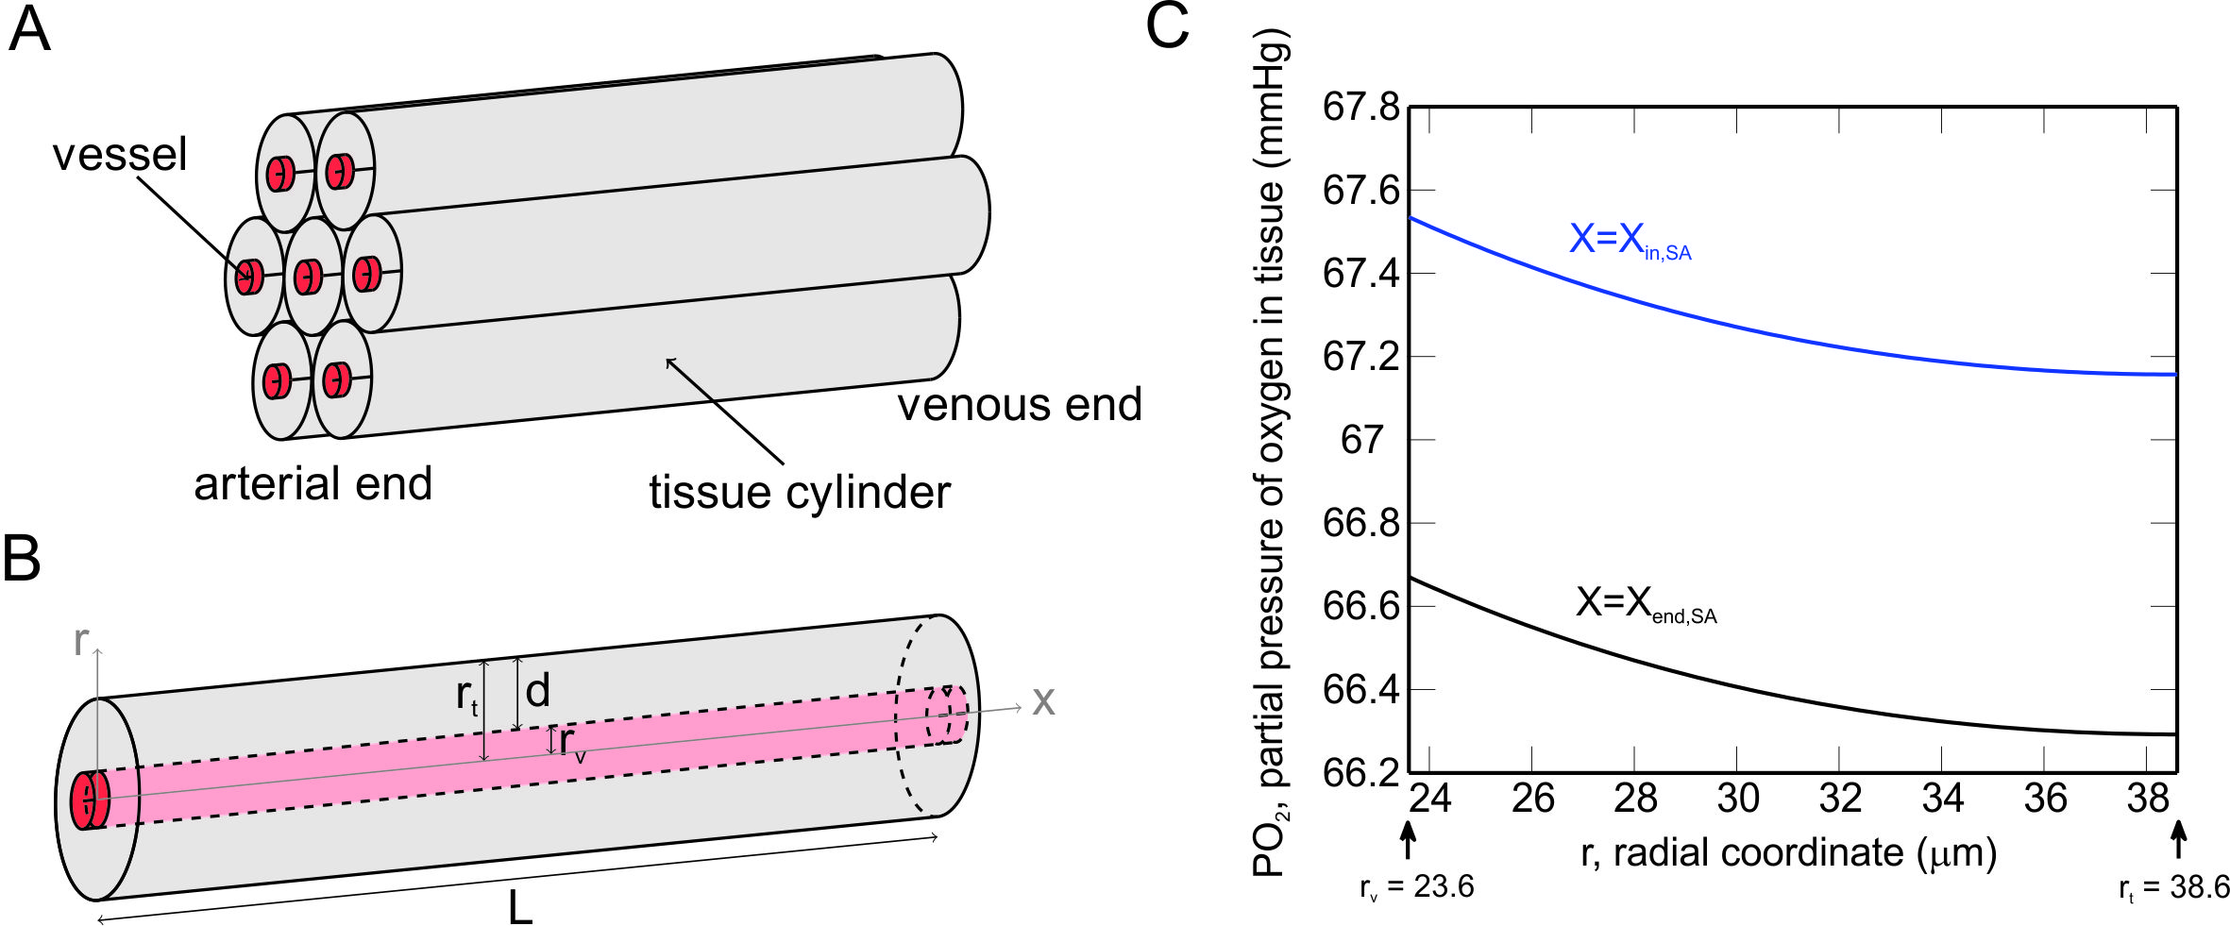
Figure 2. A Krogh cylinder model is used to predict oxygen diffusion in retinal tissue. A) Representation of a Krogh cylinder model in which vessels (red) run along the center axis of a tissue cylinder (gray). B) Depiction of a single vessel (red) supplying a cylindrical region of tissue (gray) with oxygen, where $r$ is the radial coordinate, $x$ is the distance along the network, $r_{t}$ is the radius of the tissue region, $r_{v}$ is the radius of the vessel, $d$ is the tissue width and $L$ is the vessel length. C) Distribution of the partial pressure of oxygen ${PO}_{2}\left(x,r\right)$ in the tissue surrounding the small arterioles in the radial direction at two fixed positions $x_{in,SA}= 0.807$ cm and $x_{end,SA}=1.39$ cm, $PO_{2}\left(x_{in,SA}, r_{v}\right)=67.53 mmHg$, $PO_{2}\left(x_{end,SA},r_{v}\right)=66.67 mmHg$, $M_{0}=1.65 cm^{3}O_{2}∙100 cm^{-3}\min^{-1}$, $r_{v}=23.6 μm$ ,${ r}_{t}=38.6 μm$, $k=9.4 cm^{3}O_{2} cm^{-1}mmHg^{-1}s^{-1}$.

Given the model inputs listed in Table 1 section (a), the steady-state values of the diameters $D_{i}$ and of the vascular smooth muscle activations $A_{i}$ in the LA and SA compartments are determined by integrating the system of ordinary differential equation inTable 1(b) until equilibrium is reached. It is important to note that the system also involves the quantities $T_{i}$, $T_{total,i}$ and $A_{total,i}$ which, as detailed in Table 1, are functions of the unknowns $D_{i}$ and $A_{i}$. The use of a steady state model is justified since the variation in the clinical measurements of oxygen saturation due to the cardiac cycle are not large²⁹.

Model reference state
A reference state is defined to represent conditions typical of a healthy retina. For example, the reference state values of IOP, MAP and arterial and venous oxygen saturation are set equal to the average values of these factors measured in all of the healthy individuals in this study (see Table 5). The reference state value of tissue width is chosen to be $d^{ref}=15 μm$, which corresponds to an experimental measurement of retinal intercapillary space of $30 μm$ ³⁰. In the reference state, the proportion of the tissue occupied by capillary lumens is about 2.7%, in good agreement with 2.5% measured in histological specimens³¹. Given the reference values of IOP, MAP, tissue width, and arterial oxygen saturation, the model is used to calculate the value of tissue oxygen demand ($M_{0}^{ref}=1.65 cm^{3}O_{2}∙100 cm^{-3}\min^{-1}$) that will yield the reference venous oxygen saturation level of 54%, as measured in healthy patients. This calculated rate of oxygen demand in the reference state is close in magnitude to oxygen demand levels observed experimentally ³²⁻³⁴.

Model simulations
The mathematical model presented in this study is used to conduct the following simulations:
- Theoretical investigation
The model is used to predict the theoretical effect of the artificial variation of the model inputs (Table 1(a)) on the computed outputs (Table 1(g)).
- Theoretical interpretation of clinical data
The model is used to theoretically estimate patient-specific values of oxygen demand (simulation 2A) or tissue depth (simulation 2B) that would yield the clinically-measured value of venous oxygen saturation when patient-specific inputs are considered.

The details of the algorithms implemented to perform these novel, patient-specific simulations are provided below.

Algorithm for simulation 2A:
For any individual included in the experimental study proceed as follow:
- Set the patient-specific input values for $P_{in,LA}$, $P_{out,LV}$ and $S(x=0)$ (Table 1(a)) given the clinical measurements of MAP, IOP and arterial oxygen saturation;
- set the input tissue depth equal to the reference state value $d^{ref}$ (Table 1(a));
- set the initial guess for the input oxygen demand to $M_{0}^{0}$ (Table 1(a)), for $k≥0$
- solve the model described in Table 1(b)-(f);
- compute the output of the model (Table 1(g)), which includes oxygen saturation $S^{k}\left(x\right);$
- test for convergence:
if $\frac{| measured – predicted venous oxygen saturation|}{| measured venous oxygen saturation |}≤ 5 ∙{10}^{-2}$, set ${M_{0}=M}_{0}^{k}$,
otherwise set ${M_{0}^{k+1}=M}_{0}^{k }+ δ_{M}$ and return to point a).

Algorithm for simulation 2B:
For any individual included in the experimental study proceed as follow:
- set the patient-specific input values for $P_{in,LA}$, $P_{out,LV}$ and $S(x=0)$ (Table 1(a)) given the clinical measurements of MAP, IOP and arterial oxygen saturation;
- set the input oxygen demand equal to the reference state value $M_{0}^{ref}$ (Table 1(a));
- set the initial guess for the input tissue depth to $d^{0}$ (Table 1(a)), for $k≥0$
  - solve the model described in sections Table 1(b)-(f);
  - compute the output of the model (Table 1(g)), which includes oxygen saturation $S^{k}\left(x\right);$
  - test for convergence:
if $\frac{| measured – predicted venous oxygen saturation|}{| measured venous oxygen saturation |}≤ 5 ∙{10}^{-2}$, set $d=d^{k}$,
otherwise set $d^{k+1}=d^{k}+ δ_{d}$ and return to point a).

In step iii(c) of simulations (2A) and (2B), the values of $δ_{M}$ and $δ_{d}$ are determined via the MATLAB algorithm fsolve, which is a nonlinear least-squares algorithm. For each of the algorithms (2A) and (2B), two sets of simulations are performed corresponding to the cases of functional or impaired autoregulation.

Results
Experimental data
Fig. 3 shows the scatter plot of the venous saturation data collected from healthy individuals, advanced POAG patients and advanced NTG patients ⁴. Four healthy individuals and one advanced NTG patient were excluded since no record of MAP measurement was reported. Data for mild glaucoma patients are not included in the figure since Olafsdottir and Vandewalle et al. ⁴ found no statistical difference in retinal oxygen arterial and venous saturation between healthy individuals and mild glaucoma patients. The black bars represent the average value of each group and the corresponding standard deviation. In both the advanced POAG and advanced NTG patient groups, the average value of venous oxygen saturation is higher than in healthy individuals, and the average value of arteriovenous difference is lower than in healthy individuals. No statistical difference was reported in retinal oxygen saturation when mild POAG and mild NTG patients were compared, nor when advanced POAG and advanced NTG patients were compared. The average values of IOP, MAP and oxygen saturation measured in healthy individuals, advanced POAG patients and advanced NTG patients are also reported in Table 5.

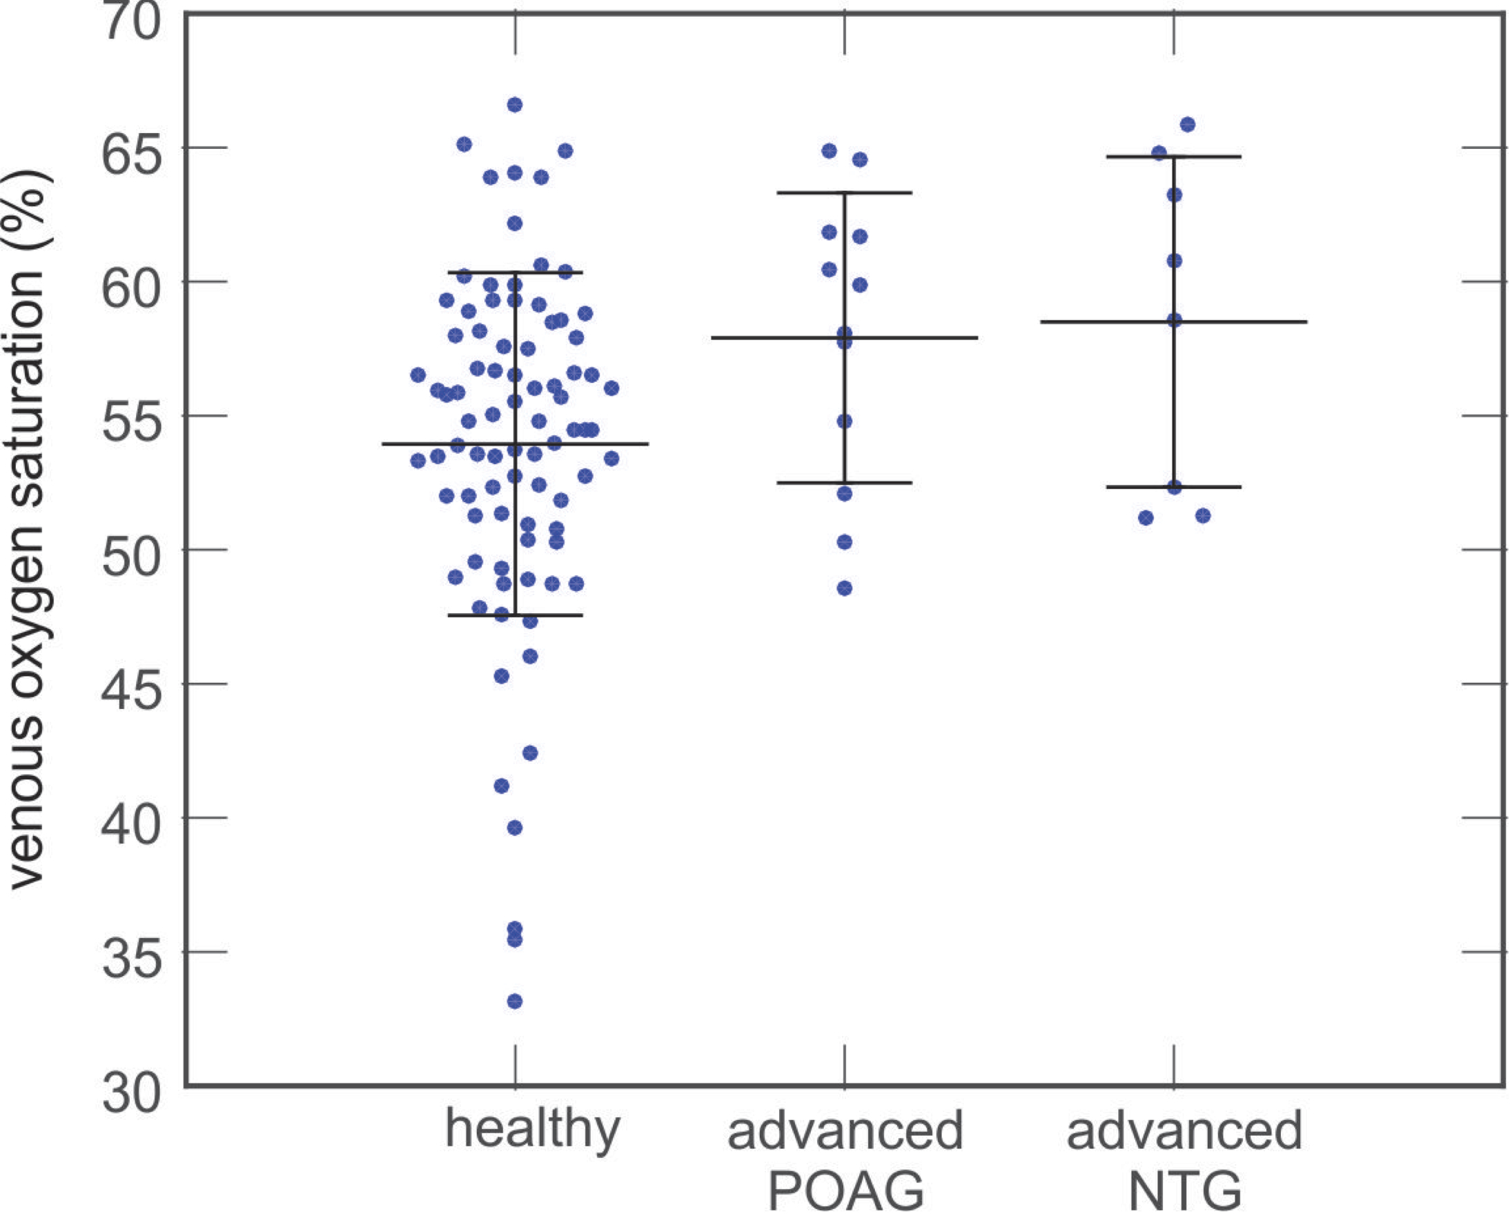
Figure 3. Venous oxygen saturation clinical data collected from healthy individuals (n=85), advanced POAG patients (n=12) and advanced NTG patients (n=8) ⁴ (blue dots). Black bars represent the mean and standard deviation of each group.

 |  | Healthy  (n=85) | Advanced POAG (n=12) | Advanced NTG (n=8)
Clinical  data | IOP [mmHg] | 15 ± 3 | 15 ± 3 | 10 ± 3
 | MAP [mmHg] | 102 ± 12 | 99 ± 10 | 109 ± 11
 | OPP [mmHg] | 53 ± 8 | 51 ± 8 | 62 ± 6
 | Arterial oxygen saturation [%] | 93 ± 4 | 95 ± 2 | 94 ± 3
 | Venous oxygen saturation [%] | 54 ± 6 | 58 ± 5 | 58 ± 6
Reference values | $$M_{0}^{ref} [cm^{3}O_{2}∙100 cm^{-3}\min^{-1}]$$ | 1.65
 | $$d^{ref} [μm]$$ | 15

Table 5. Clinical average values of intraocular pressure (IOP, in mmHg), mean arterial pressure (MAP, in mmHg), ocular perfusion pressure (OPP $= \frac{2}{3}$ MAP – IOP, in mmHg), retinal arterial oxygen saturation and retinal venous oxygen saturation measured in healthy individuals, advanced (visual field MD$≥$10 dB) primary open-angle glaucoma (POAG, IOP $>$21 mmHg) patients and advanced normal tension glaucoma (NTG, IOP$≤$21 mmHg) patients ⁴. Reference state parameter values are highlighted in bold.

Theoretical investigation
Fig. 4 shows the scatter plot of the venous oxygen saturation data collected from healthy individuals as a function of ocular perfusion pressure ($OPP= \frac{2}{3} MAP-IOP$). The clinical data (blue dots) are compared to the mathematical model prediction (solid curve) of venous saturation as OPP is varied. Reference state values of IOP, MAP, arterial oxygen saturation, ${M_{0}}^{ref}$ and $d^{ref}$ are used to produce the model simulated curve. Since the model predictions generated by varying MAP and holding IOP constant or by varying IOP and holding MAP constant are nearly identical, only one curve is shown as OPP is varied.

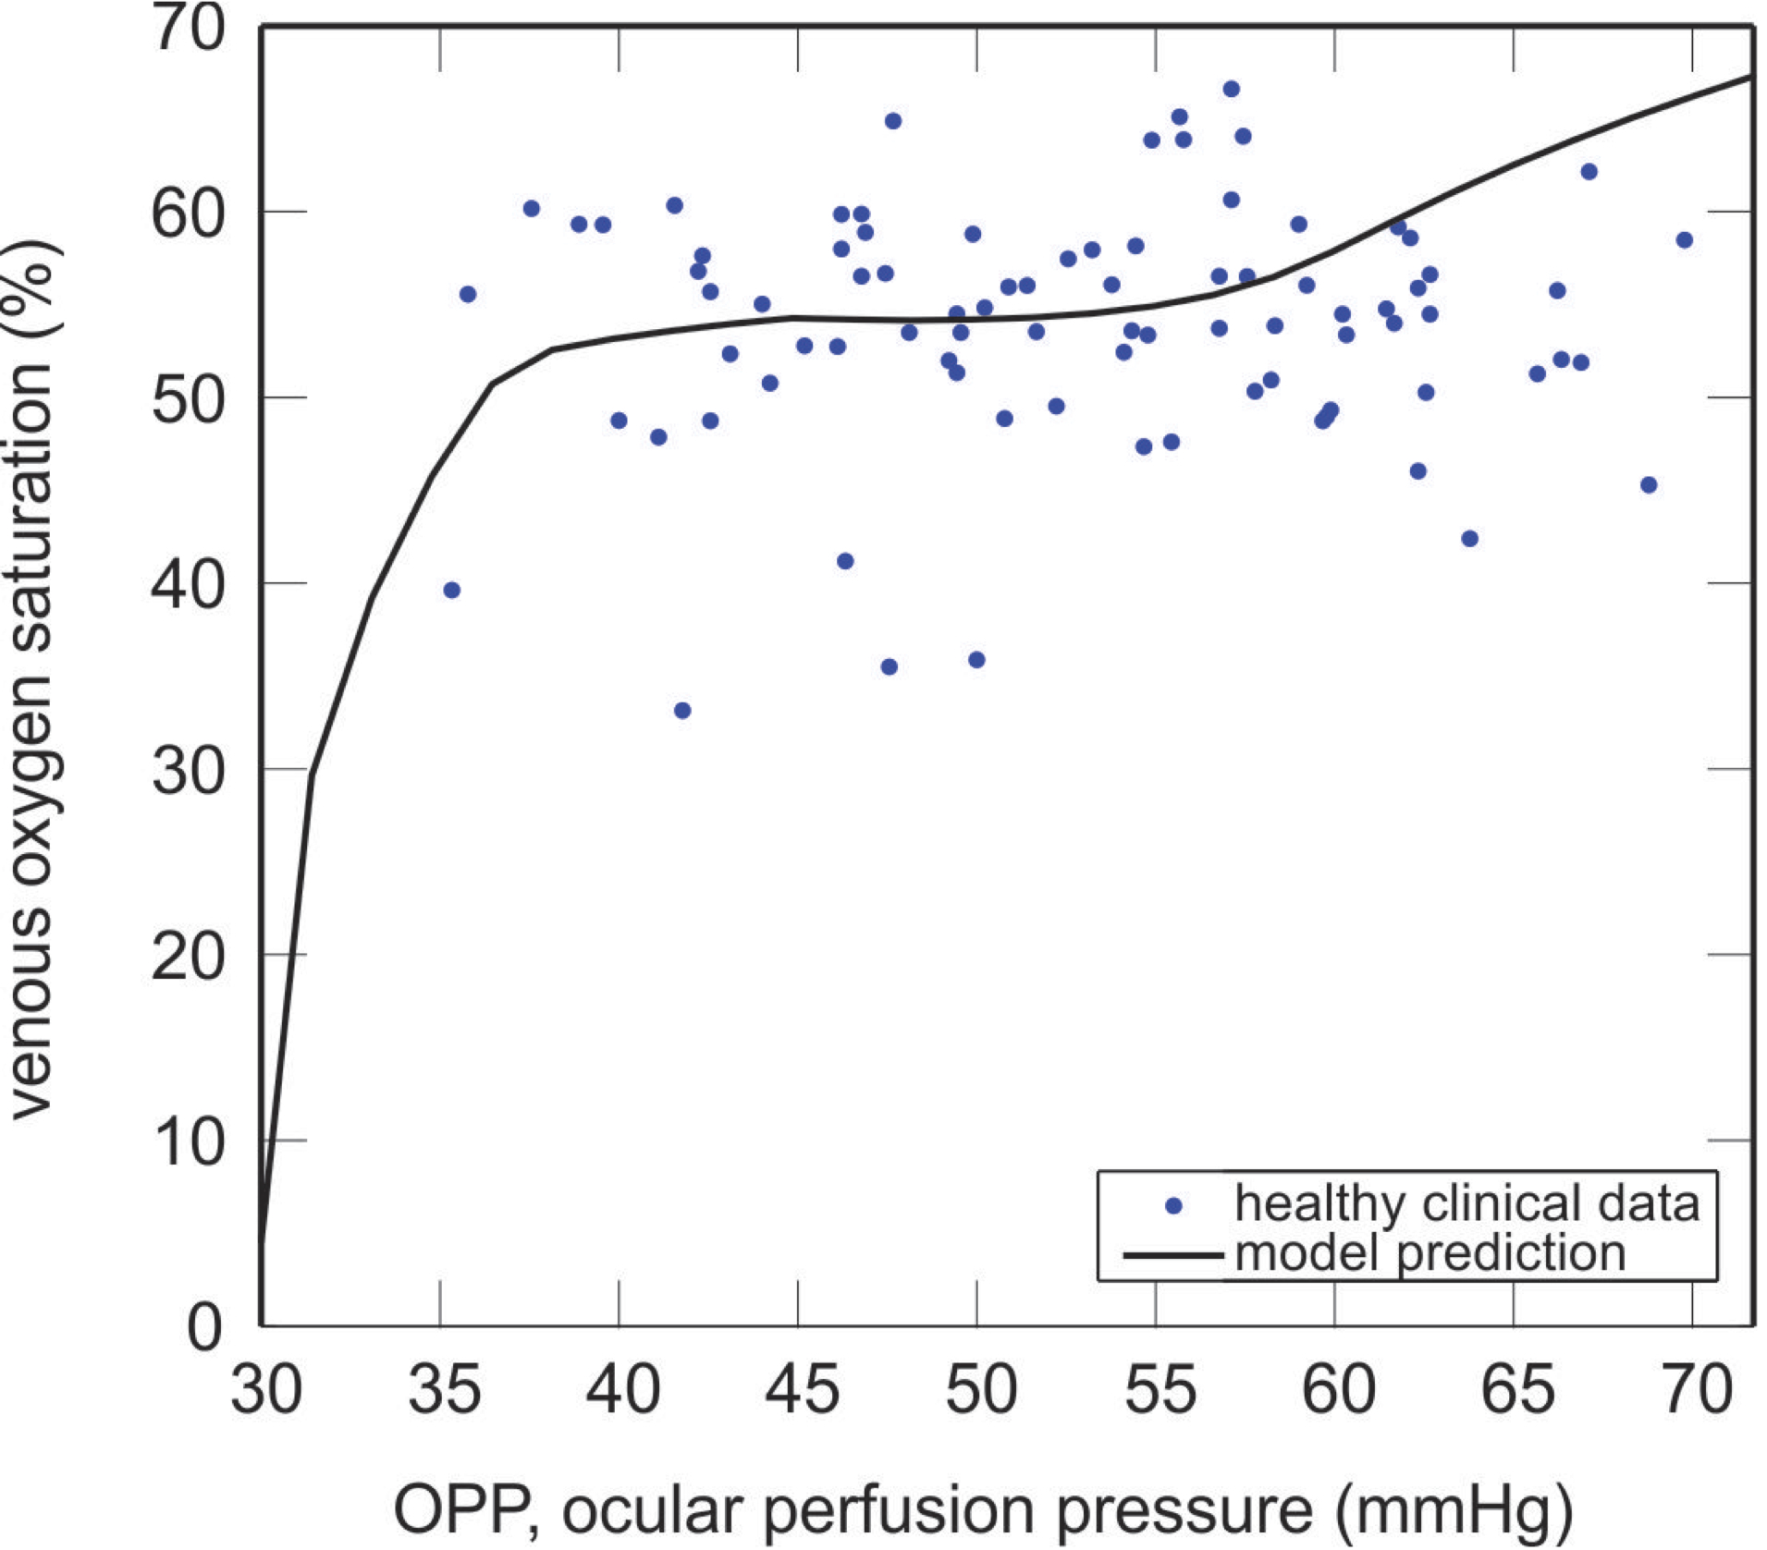
Figure 4. A scatter plot of the venous saturation clinical data (blue dots) collected from healthy individuals is compared with theoretical predictions (solid black curve) as OPP is varied. Here, a range of OPP values is generated by holding IOP constant at its reference state value (15 mmHg) while varying MAP between 67 and 130 mmHg.

Since the clinical data ⁴ show an increase in venous saturation in advanced glaucoma patients, the mathematical model is used to theorize three possible explanations for increased venous saturation:

- A decrease in tissue oxygen demand ($M_{0}$): If less oxygen is consumed by the tissue, higher levels of venous oxygen saturation are predicted;
- An impairment of blood flow autoregulation: If the most influential autoregulation mechanisms (conducted metabolic and/or local carbon dioxide response mechanisms) are impaired, higher levels of venous oxygen saturation are predicted for certain ranges of OPP;
- A decrease in tissue width (d): If the volume of tissue supplied by each capillary or arteriole is decreased, higher levels of venous oxygen saturation are predicted.

As shown in Fig. 5A, the model predicts a decrease in venous oxygen saturation as oxygen demand is increased provided that all other factors (MAP, IOP, d, arterial blood saturation and functionality of autoregulation) are not altered. Fig. 5B depicts case (1) in which venous oxygen saturation is shown as a function of OPP for two different values of $M_{0}:$ ${M_{0}}^{ref}=1.65 cm^{3}O_{2}∙100 cm^{-3}\min^{-1}$ (blue curve) and $M_{0}=1.32 cm^{3}O_{2}∙100 cm^{-3}\min^{-1}$ (red curve). These curves show the effect of a 20% decrease in oxygen demand on the model predictions of venous saturation. It is interesting to observe that this decrease in oxygen demand causes variable increases in venous oxygen saturation depending on the value of OPP.

Fig. 5C provides evidence for case (2), namely that an increase in venous oxygen saturation can also occur over a certain range of OPP values when autoregulation is impaired. In this case, ${M_{0}}^{ref}=1.65 cm^{3}O_{2}∙100 cm^{-3}\min^{-1}$ for both curves, but the metabolic and carbon dioxide autoregulation mechanisms are impaired (i.e., absent) in the black dashed curve.

Fig. 5D shows that a decrease in tissue width supplied by each arteriole or capillary in the Krogh cylinder model can also lead to an increase in venous oxygen saturation, as outlined in case (3). Decreasing the tissue width leads to a decrease in the total tissue volume supplied by the retinal vasculature. Fig. 5D depicts the effect of decreasing tissue width from $d^{ref}=15 μm$ (blue curve) to $d=13 μm$ (green curve).

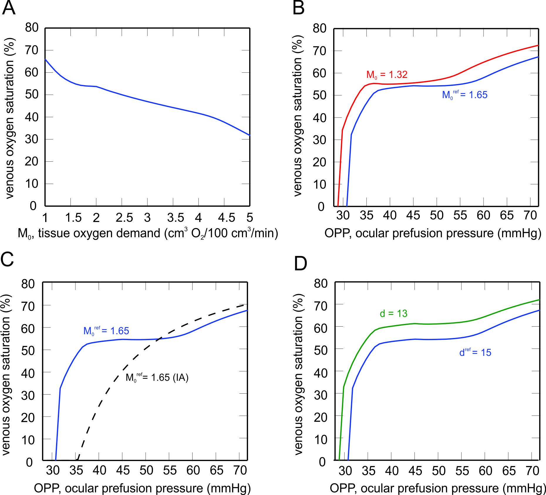

Figure 5. A) Decrease in venous oxygen saturation as tissue oxygen demand (M₀) is increased, given constant reference state values of MAP, IOP and arterial oxygen saturation. The remaining panels highlight the three-part theoretical investigation of the effects of B) oxygen demand (M₀), C) impaired autoregulation (IA) and D) tissue width (d) on model predictions of venous oxygen saturation as OPP is varied. Each scenario is compared with the model prediction of the reference state (blue curve) in which ${M_{0}}^{ref}$= 1.65 cm³ O₂/100 cm³/min, $d^{ref}=15 μm$, and autoregulation is functional.

Theoretical interpretation of clinical data
Fig. 6 summarizes the model predicted values of oxygen demand (gray) or tissue width (blue) that will yield the clinically observed venous saturation levels (Fig. 3) for each individual in the healthy, advanced POAG and advanced NTG populations. Model predictions for mild POAG and NTG patient groups are not included since the venous saturation levels did not differ from healthy individuals. The model predicts that the observed increase in venous saturation in advanced POAG patients is accompanied by a decrease in oxygen demand, whereas no change in oxygen demand is predicted in advanced NTG patients. A slightly lower tissue width is predicted in POAG patients to yield increased venous saturation but not in NTG patients. These trends are observed regardless of whether autoregulation is functioning or impaired. Table 6 lists the mean and standard deviation of the oxygen demand and tissue width model predictions depicted in Fig. 6. All clinical measures were used except for a few cases in which the tolerance of the optimization procedure employed to find $M_{0}$ (2 healthy patients, 1 advanced POAG patient and 1 advanced NTG patient) and $d$ (2 healthy patients and 1 advanced NTG patient) was not achieved.

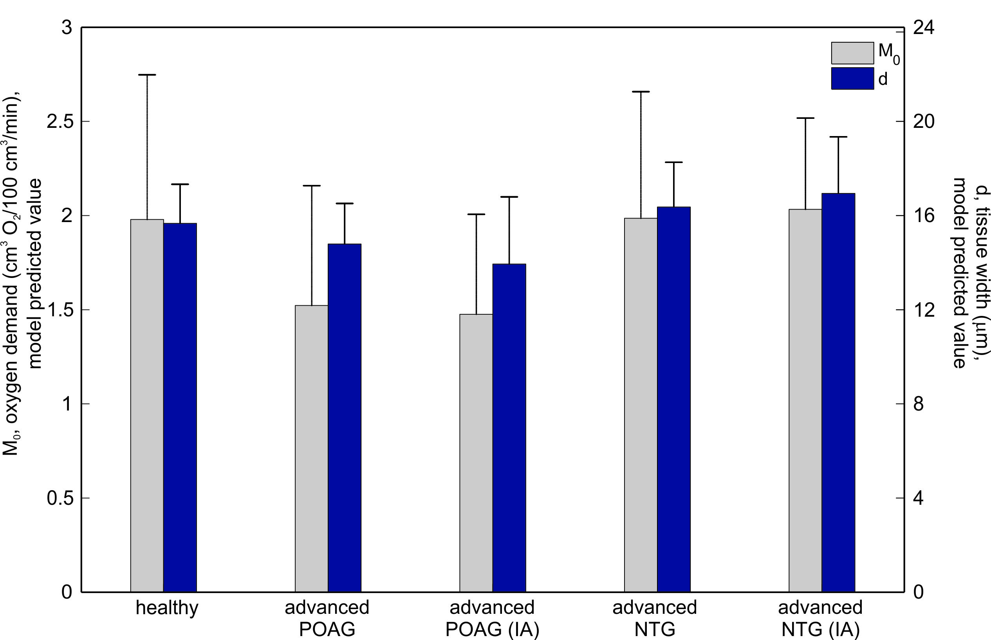

Figure 6. Model predicted levels of tissue oxygen demand (M₀) and tissue width (d) that yield the venous saturation clinical data collected from each individual in the healthy, advanced POAG and advanced NTG populations ⁴. Model predictions are also provided when autoregulation is impaired (IA) in advanced POAG and NTG patients. Black bars represent mean and standard deviation of each group.
 | Healthy | Advanced  POAG | Advanced  POAG (IA) | Advanced  NTG | Advanced  NTG (IA)
$$M_{0} [cm^{3}O_{2}∙100 cm^{-3}\min^{-1}]$$ | 1.98 ± 0.77 | 1.52 ± 0.64 | 1.48 ± 0.53 | 1.99 ± 0.67 | 2.03 ± 0.48
$$d [μm]$$ | 15.66 ± 1.66 | 14.79 ±1.72 | 13.94 ± 2.85 | 16.36 ±1.90 | 16.94 ±2.40

Table 6. Model predicted levels of tissue oxygen demand ($M_{0}$) and tissue width ($d$) that yield the venous saturation clinical data collected from healthy, advanced POAG and advanced NTG patients ⁴.

It is important to note that the average values of oxygen demand and tissue width calculated for the healthy population (reported in Table 6) are not equal to the reference state values of oxygen demand and tissue width (reported in Table 5). In Table 5, the values $M_{0}^{ref}$ and $d^{ref}$ are computed from average values of IOP, MAP and arterial saturation obtained from the healthy population. In Table 6, the values of $M_{0}$ and $d$ are computed using the MAP, IOP and arterial saturation from each individual and then averaging the resulting values in each population.

Based on the model predictions summarized in Fig. 6 and Table 6, Fig. 7A shows the model predicted curves of venous oxygen saturation for $M_{0}=1.98 cm^{3}O_{2}∙100 cm^{-3}\min^{-1}$ (blue curve) and decreased $M_{0}=1.52 cm^{3}O_{2}∙100 cm^{-3}\min^{-1}$ (black curve) as well as the average clinical values of venous saturation and OPP in healthy individuals (asterisk) and advanced POAG patients (square). In Fig. 7B, $M_{0}=1.98 cm^{3}O_{2}∙100 cm^{-3}\min^{-1}$ and $d^{ref}=15 μm$ are fixed for both curves, but autoregulation is assumed to be impaired for the black dashed curve. These model predictions are compared with average clinical values of venous saturation and OPP measured in healthy individuals (asterisk) and advanced NTG patients (square).

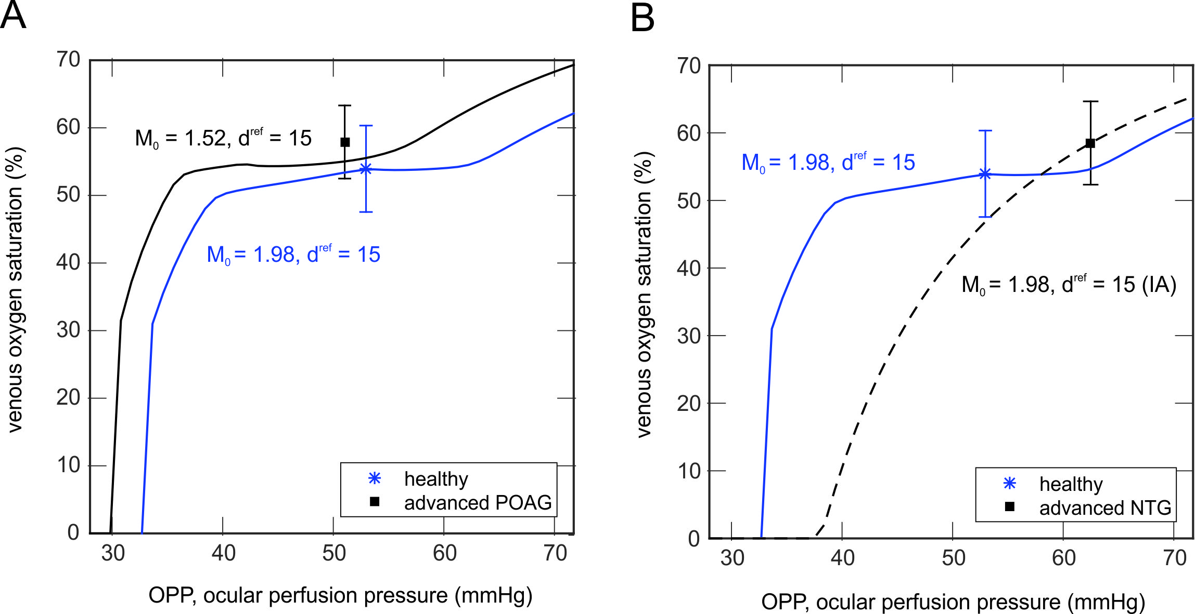

Figure 7. Model predicted curves of venous oxygen saturation as OPP is varied are shown with average values of venous oxygen saturation and OPP measured clinically. A) The observed increase in the average venous saturation in healthy individuals (blue asterisk) and in advanced POAG patients (black square) is compared with model predicted levels of venous saturation for decreased levels of tissue demand. B) The observed increase in the average venous saturation in healthy individuals (blue asterisk) and advanced NTG patients (black square) is compared with model predicted levels of venous saturation when autoregulation is impaired (IA).

Discussion
Experimental data
Retinal vessel oxygen saturation was measured in healthy individuals and glaucoma patients using a non-invasive retinal oximeter. The measurements indicated that patients with advanced glaucoma (both POAG and NTG patients) exhibited higher venous oxygen saturation (and consequently a lower arteriovenous difference in oxygen saturation) compared with healthy individuals. Other studies ^{21, 22} have confirmed these findings, and it has been previously hypothesized ⁴ that the observed increase in venous saturation is likely a secondary effect of glaucomatous atrophy and not a primary cause of glaucoma, citing the absence of hypoxia in advanced glaucoma patients as supporting evidence. However, the number of advanced glaucoma patients in these studies (including the current one) was rather small, and many patients were under active ophthalmological care. Thus, additional studies, ideally progressive in nature and conducted in patients with very high IOP and very low OPP, are needed in order to draw more definitive conclusions.

Theoretical investigation
This study implements a theoretical model based on fundamental hemodynamic and mechanical principles to predict venous oxygen saturation levels given patient-specific values of MAP, IOP and arterial oxygen saturation. The model predictions using the reference state values of these factors align well with the observed venous saturation levels collected from healthy individuals (Fig. 4).

A Krogh cylinder model is used to describe the diffusion of oxygen into tissue; this Krogh model is applied in the classical sense in which the oxygen-supplying vessel runs along the central axis of a tissue cylinder. However, such an assumption may not be the most appropriate for retinal tissue, since the majority of the tissue that retinal vessels feed is typically located “below” the vessels ³⁵. Some mathematical models have described oxygen diffusion through the retinal tissue layers ³⁶⁻³⁹ but did not consistently include a description of blood flow and autoregulation in the retinal vasculature. It would be an interesting research direction to enhance the model in the current study to include a more realistic geometric arrangement of vessels and tissue. It has also been shown that oxygen diffuses directly from the CRA to the CRV, bypassing the retinal microcirculation, due to the close anatomical relation between the central retinal vessels in the center of the optic nerve ^{40, 41}. The current model could be extended to include the effects of this counter-current exchange phenomenon.

Theoretical interpretation of clinical data
In this study, a mathematical model is used to offer possible explanations for the observed trends in oximetry data collected in healthy individuals and glaucoma patients. Specifically, the model shows that a decrease in oxygen demand, an impairment of autoregulation or a decrease in tissue width can all lead to increased venous saturation levels. It is important to note that although the model predictions offer each of these scenarios as a possible explanation, not all of them are physiologically relevant when describing the details of glaucoma. For example, suggesting a decrease in the Krogh cylinder tissue width as an explanation for the increased venous saturation levels observed in glaucoma is not consistent with the reduced vascularization observed in some glaucoma patients ^{14-16, 31}. However, the interconnection of tissue width and retinal atrophy suggests that future insight could be gained by using the model to assess the effects of altering multiple factors at once.

The patient-specific model optimizations presented in this study (Fig. 7) suggest that there might be different explanations for the increased venous saturation levels observed among advanced POAG patients and advanced NTG patients. Specifically, a decrease in oxygen demand may be more relevant to the increase in venous saturation observed in advanced POAG (Fig. 7A), while impaired autoregulation mechanisms may be more relevant to the increase in venous saturation observed in advanced NTG (Fig. 7B). This finding also suggests that vascular changes might occur primary to glaucomatous damage in NTG patients. Of note, the relation found between NTG patients and the impairment of blood flow autoregulation has been proposed previously ^{42, 43}. Importantly, impaired blood flow autoregulation could play a role in all advanced glaucoma patients, but to varying extents, as suggested by Fig.6. Additional theoretical investigations, ideally coupled with statistical methods and conducted on a wider set of glaucoma patients, are needed to confirm the model findings.

In a study that measured venous oxygen saturation under altered light and dark conditions⁴⁴, an increase in arterial and venous saturation was observed, although the arteriovenous difference in oxygen saturation was reported to be stable. The authors hypothesized that the observed increase in venous saturation was accompanied by an increase in oxygen consumption, which opposes the hypothesis offered in the current study. However, in the light and dark study⁴⁴, the oxygen demand increased mostly in the outer retina due to the increased photoreceptor activity. The outer retina is not directly accounted for in the model presented here, which therefore may limit the possible model predictions under various conditions. Additionally, it is possible that a compromised ocular circulation renders an individual more susceptible to a given IOP, thereby representing a confounding factor that falls outside of strict primary or secondary classifications.

Conclusions
Overall, this model provides an important step in assessing and quantifying observations in clinical data. Instead of performing statistical analyses on measured observations, the model provides a mechanical framework built upon blood flow principles that can be used to make independent predictions of the same measured quantities while varying MAP, IOP and arterial oxygen saturation. Overall, the study suggests that the primary mechanisms leading to increased venous saturation in advanced cases of glaucoma might differ between POAG and NTG patients. It is hypothesized that the increased saturation levels are more likely to be explained by decreased oxygen demand in POAG patients and impaired autoregulation in NTG patients. In future studies, the model will continue to be used to address the open question of whether vascular changes occur primary or secondary to glaucomatous damage, possibly identifying subgroups of patients where vascular pathogenic mechanisms play a more significant role. However, progressive data and larger data sets are needed to confirm the hypotheses formulated on the basis of the model predictions.

Acknowledgments
The authors would like to thank Sien Boons, Asbjorg Geirsdottir and Jona Valgerdur Kristjansdottir for their help with gathering data. The authors acknowledge support from: National Science Foundation Grant DMS-1224195 (JA, GG), National Institutes of Health Grant 1R21EY022101-01A1 (AH, BAS), unrestricted grant from Research to Prevent Blindness, Inc. (AH, BAS), Chateaubriand fellowship STEM of the Embassy of France in the United States (LC), Chair Gutenberg funds of the Cercle Gutenberg, Strasbourg, France (GG), grant from the Icelandic Centre for Research (Rannis grant no. 100429021) (OBO), the Landspitali-University Hospital Research Fund (no. A-2013-023) (OBO), grant from the Fonds Wetenschappelijk Onderzoek - Vlaanderen and unrestricted grant from Merck Sharp and Dohme (no. B322201010013) (EV).

References
1. Moore D, Harris A, Wudunn D, Kheradiya N, Siesky B. Dysfunctional regulation of ocular blood flow: A risk factor for glaucoma? Clin Ophthalmol. 2008;2(4):849-61.
2. Harris A, Kagemann L, Ehrlich R, Rospigliosi C, Moore D, Siesky B. Measuring and interpreting ocular blood flow and metabolism in glaucoma. Canadian journal of ophthalmology Journal canadien d'ophtalmologie. 2008;43(3):328-36.
3. Olafsdottir OB, Hardarson SH, Gottfredsdottir MS, Harris A, Stefansson E. Retinal oximetry in primary open-angle glaucoma. Investigative ophthalmology & visual science. 2011;52(9):6409-13.
4. Olafsdottir OB, Vandewalle E, Abegao Pinto L, Geirsdottir A, De Clerck E, Stalmans P, et al. Retinal oxygen metabolism in healthy subjects and glaucoma patients. The British journal of ophthalmology. 2014;98(3):329-33.
5. Geirsdottir A, Hardarson SH, Olafsdottir OB, Stefansson E. Retinal oxygen metabolism in exudative age-related macular degeneration. Acta ophthalmologica. 2014;92(1):27-33.
6. Michelson G, Scibor M. Intravascular oxygen saturation in retinal vessels in normal subjects and open-angle glaucoma subjects. Acta ophthalmologica Scandinavica. 2006;84(3):289-95.
7. Abegao Pinto L, Vandewalle E, De Clerck E, Marques-Neves C, Stalmans I. Ophthalmic artery Doppler waveform changes associated with increased damage in glaucoma patients. Investigative ophthalmology & visual science. 2012;53(4):2448-53.
8. Akarsu C, Bilgili MY. Color Doppler imaging in ocular hypertension and open-angle glaucoma. Graefe's archive for clinical and experimental ophthalmology = Albrecht von Graefes Archiv fur klinische und experimentelle Ophthalmologie. 2004;242(2):125-9.
9. Butt Z, O'Brien C, McKillop G, Aspinall P, Allan P. Color Doppler imaging in untreated high- and normal-pressure open-angle glaucoma. Investigative ophthalmology & visual science. 1997;38(3):690-6.
10. Rojanapongpun P, Drance SM, Morrison BJ. Ophthalmic artery flow velocity in glaucomatous and normal subjects. The British journal of ophthalmology. 1993;77(1):25-9.
11. Tobe LA, Harris A, Hussain RM, Eckert G, Huck A, Park J, et al. The role of retrobulbar and retinal circulation on optic nerve head and retinal nerve fibre layer structure in patients with open-angle glaucoma over an 18-month period. The British journal of ophthalmology. 2015;99(5):609-12.
12. Grieshaber MC, Flammer J. Blood flow in glaucoma. Current opinion in ophthalmology. 2005;16(2):79-83.
13. Flammer J. The vascular concept of glaucoma. Survey of ophthalmology. 1994;38 Suppl:S3-6.
14. Jia Y, Morrison JC, Tokayer J, Tan O, Lombardi L, Baumann B, et al. Quantitative OCT angiography of optic nerve head blood flow. Biomedical optics express. 2012;3(12):3127-37.
15. Jia Y, Tan O, Tokayer J, Potsaid B, Wang Y, Liu JJ, et al. Split-spectrum amplitude-decorrelation angiography with optical coherence tomography. Optics express. 2012;20(4):4710-25.
16. Jia Y, Wei E, Wang X, Zhang X, Morrison JC, Parikh M, et al. Optical coherence tomography angiography of optic disc perfusion in glaucoma. Ophthalmology. 2014;121(7):1322-32.
17. Harris A, Jonescu-Cuypers C, Kagemann L, Ciulla T, Krieglstein G. Atlas of ocular blood flow: Butterworth-Heinemann; 2003.
18. Weinreb R, Harris A. Ocular blood flow in glaucoma: the 6th consensus report of the world glaucoma association. Amsterdam, The Netherlands: Kugler Publications; 2009.
19. Ito M, Murayama K, Deguchi T, Takasu M, Gil T, Araie M, et al. Oxygen saturation levels in the juxta-papillary retina in eyes with glaucoma. Experimental eye research. 2008;86(3):512-8.
20. Vandewalle E, Abegao Pinto L, Olafsdottir OB, De Clerck E, Stalmans P, Van Calster J, et al. Oximetry in glaucoma: correlation of metabolic change with structural and functional damage. Acta ophthalmologica. 2014;92(2):105-10.
21. Mordant DJ, Al-Abboud I, Muyo G, Gorman A, Harvey AR, McNaught AI. Oxygen saturation measurements of the retinal vasculature in treated asymmetrical primary open-angle glaucoma using hyperspectral imaging. Eye. 2014;28(10):1190-200.
22. Ramm L, Jentsch S, Peters S, Augsten R, Hammer M. Investigation of blood flow regulation and oxygen saturation of the retinal vessels in primary open-angle glaucoma. Graefe's archive for clinical and experimental ophthalmology = Albrecht von Graefes Archiv fur klinische und experimentelle Ophthalmologie. 2014;252(11):1803-10.
23. Arciero J, Harris A, Siesky B, Amireskandari A, Gershuny V, Pickrell A, et al. Theoretical analysis of vascular regulatory mechanisms contributing to retinal blood flow autoregulation. Investigative ophthalmology & visual science. 2013;54(8):5584-93.
24. Pries AR, Secomb TW, Gessner T, Sperandio MB, Gross JF, Gaehtgens P. Resistance to Blood-Flow in Microvessels in-Vivo. Circ Res. 1994;75(5):904-15.
25. Ye GF, Moore TW, Buerk DG, Jaron D. A compartmental model for oxygen-carbon dioxide coupled transport in the microcirculation. Annals of biomedical engineering. 1994;22(5):464-79.
26. Orgul S, Cioffi GA, Wilson DJ, Bacon DR, Van Buskirk EM. An endothelin-1 induced model of optic nerve ischemia in the rabbit. Investigative ophthalmology & visual science. 1996;37(9):1860-9.
27. Orgul S, Gugleta K, Flammer J. Physiology of perfusion as it relates to the optic nerve head. Survey of ophthalmology. 1999;43 Suppl 1:S17-26.
28. Causin P, Guidoboni G, Malgaroli F, Sacco R, Harris A. Blood flow mechanics and oxygen transport and delivery in the retinal microcirculation: multiscale mathematical modeling and numerical simulation. Biomechanics and modeling in mechanobiology. 2015.
29. Palsson O, Geirsdottir A, Hardarson SH, Olafsdottir OB, Kristjansdottir JV, Stefansson E. Retinal oximetry images must be standardized: a methodological analysis. Investigative ophthalmology & visual science. 2012;53(4):1729-33.
30. Michelson G, Welzenbach J, Pal I, Harazny J. Functional imaging of the retinal microvasculature by scanning laser Doppler flowmetry. International ophthalmology. 2001;23(4-6):327-35.
31. Quigley HA. Neuronal death in glaucoma. Progress in retinal and eye research. 1999;18(1):39-57.
32. Medrano CJ, Fox DA. Oxygen consumption in the rat outer and inner retina: light- and pharmacologically-induced inhibition. Experimental eye research. 1995;61(3):273-84.
33. Braun RD, Linsenmeier RA, Goldstick TK. Oxygen consumption in the inner and outer retina of the cat. Investigative ophthalmology & visual science. 1995;36(3):542-54.
34. Wangsa-Wirawan ND, Linsenmeier RA. Retinal oxygen: fundamental and clinical aspects. Archives of ophthalmology. 2003;121(4):547-57.
35. Kur J, Newman EA, Chan-Ling T. Cellular and physiological mechanisms underlying blood flow regulation in the retina and choroid in health and disease. Progress in retinal and eye research. 2012;31(5):377-406.
36. Cringle SJ, Yu DY. A multi-layer model of retinal oxygen supply and consumption helps explain the muted rise in inner retinal PO(2) during systemic hyperoxia. Comparative biochemistry and physiology Part A, Molecular & integrative physiology. 2002;132(1):61-6.
37. Haugh LM, Linsenmeier RA, Goldstick TK. Mathematical models of the spatial distribution of retinal oxygen tension and consumption, including changes upon illumination. Annals of biomedical engineering. 1990;18(1):19-36.
38. Lau JC, Linsenmeier RA. Oxygen consumption and distribution in the Long-Evans rat retina. Experimental eye research. 2012;102:50-8.
39. Roos MW. Theoretical estimation of retinal oxygenation during retinal artery occlusion. Physiological measurement. 2004;25(6):1523-32.
40. Riva CE, Pournaras CJ, Tsacopoulos M. Regulation of local oxygen tension and blood flow in the inner retina during hyperoxia. Journal of applied physiology. 1986;61(2):592-8.
41. Bek T. Regional morphology and pathophysiology of retinal vascular disease. Progress in retinal and eye research. 2013;36:247-59.
42. Abegao Pinto L, Vandewalle E, De Clerck E, Marques-Neves C, Stalmans I. Lack of spontaneous venous pulsation: possible risk indicator in normal tension glaucoma? Acta ophthalmologica. 2013;91(6):514-20.
43. Oettli A, Gugleta K, Kochkorov A, Katamay R, Flammer J, Orgul S. Rigidity of retinal vessel in untreated eyes of normal tension primary open-angle glaucoma patients. Journal of glaucoma. 2011;20(5):303-6.
44. Hardarson SH, Basit S, Jonsdottir TE, Eysteinsson T, Halldorsson GH, Karlsson RA, et al. Oxygen saturation in human retinal vessels is higher in dark than in light. Investigative ophthalmology & visual science. 2009;50(5):2308-11.

